CMS - Provider Enrollment and Screening Portal Migration to WebSphere

Deployment Guide

Revision History
Author | Revision Number | Date
TCSASSEMBER | 1.0 | 04.24.2013

1. Deployment Instructions 3
2. Organization of Submission 3
3. Application Setup 3
3.1 Software Stack 3
3.2 Database Setup 3
3.3 Install Guvnor 3
3.4 Websphere Setup 6
3.5 Build Scripts Setup 8
3.6 Configuration Files 8
4. Deployment Instructions 8
5. Starting 9
6. Verification 9
7. Resource Contact List 11

Deployment Instructions

Organization of Submission

- cms-business-model – contains model files
- cms-business-process – contains the process logic
- cms-portal-services – the enterprise application, including dependencies
- cms-web – the front end code
- db – database setup related files
- docs – contains the deployment guide (this document) and other relevant files for deployment
- services – utility jar shared by web and ejbs

Application Setup

Software Stack

    - Oracle 11g

- Please download from Oracle and install per product documentation.

    - Guvnor 5.2

- Download the software from http://download.jboss.org/drools/release/5.2.0.Final/

    - Websphere 8.5

- Download the software from IBM and install per product documentation. This guide refers to the application server installation folder as <appserver.dir>

Database Setup

Download the database dump file from this thread:

http://apps.topcoder.com/forums/?module=Thread&threadID=786941&start=0

And import it to your installation (via TOAD, command line or other tools like SQLDEVELOPER).

WAS8+ uses JPA2 vs Jboss 5 which uses JPA1 so there are some differences in the supported mappings, execute the following statements in your SQL client:

ALTER TABLE PROCESSINSTANCEINFO ADD ID NUMBER(19);
ALTER TABLE EVENTTYPES RENAME COLUMN ELEMENT TO EVENTTYPES;

Install Guvnor

- EXTRACT guvnor-5.2.0.Final-tomcat.war(from the binaries folder of the distribution) to a temporary folder

- Patch the war(just overwrite) with the files from docs/guvnor-was8-patch/
Note: on components.xml, please change the repository root directory to an existing folder

<key>repository.root.directory</key><value>C:/opt/repo</value>

- Package the war again and proceed with installation

Login to the websphere console, e.g. https://localhost:9043/ibm/console/logon.jsp

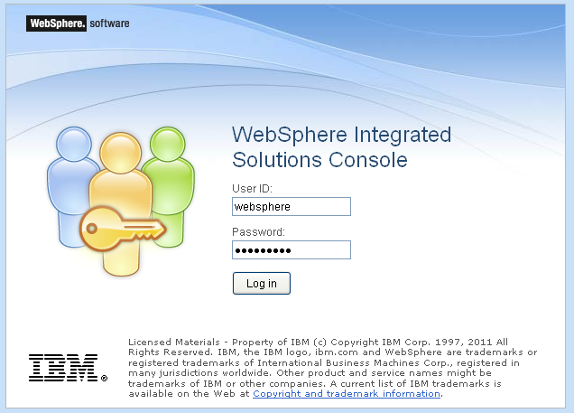

- Go to the new application installation page

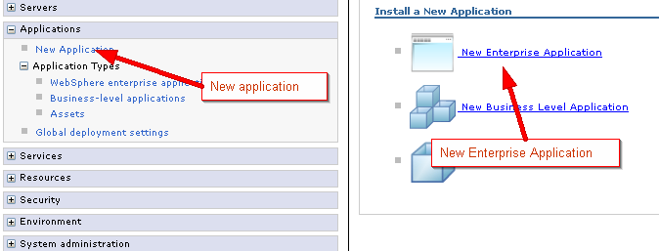

- Follow the wizard and select only the defaults until it asks for a context path, enter /cms-rules

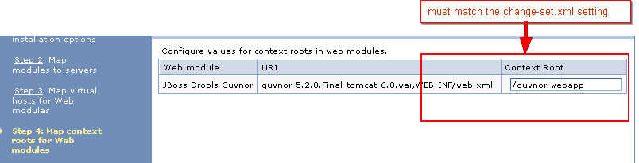

- After finishing the setup and saving the configuration, start the application
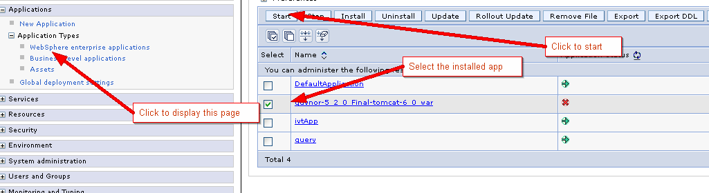

- Setup a custom properties required by the seam filter, the following are necessary:

On the web container, set:

com.ibm.ws.webcontainer.invokeFiltersCompatibility=true
com.ibm.ws.webcontainer.invokeFilterInitAtStartup=true

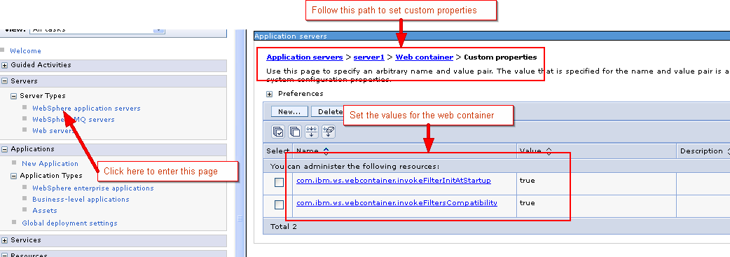

On the entire server, disable the JAXRS default (apache wink) since it will collide with the CXF used by guvnor

com.ibm.websphere.jaxrs.server.DisableIBMJAXRSEngine=true

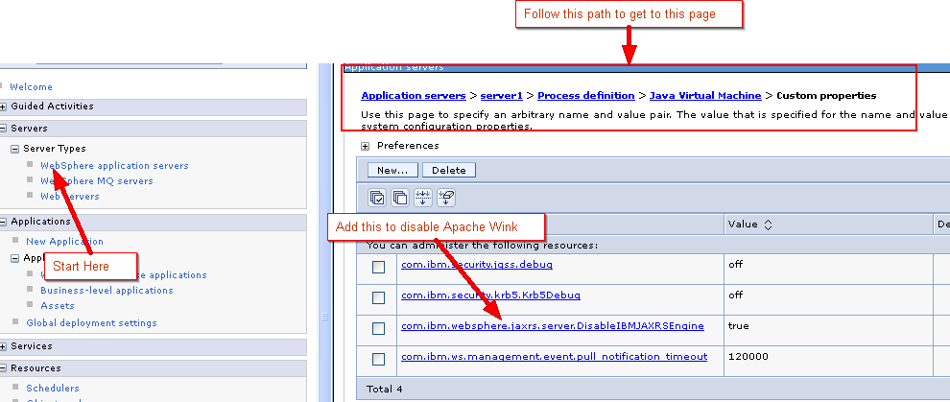

- Restart websphere.
- Open the guvnor console http://localhost:9080/guvnor-webapp

  - Click tab “Knowledge Bases”
  - Click “Create New”
  - Select “New Package”
  - Import all the DRL files from /cms-business-process/src/main/resources

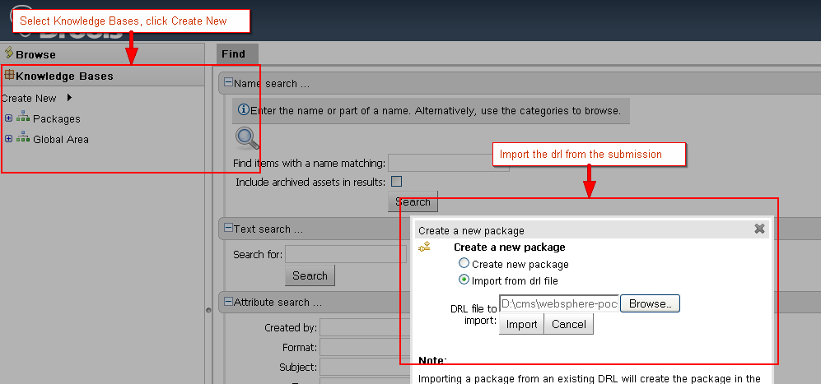

Websphere Setup

Note: You may run into out of memory errors using the default heap size, please adjust it to at least 1GB (less may work, but this was tested using 1GB), you may check the websphere documentation or follow the below guide to setting the heap size, please restart websphere after setting a new value.

http://www.mkyong.com/websphere/how-to-increase-websphere-jvm-memory/

You need to setup 2 datasources and a mail provider. The next steps assume that you are logged in to WAS8.5 console

- To setup authentication (db user), from the left navigation go to Security > Global Security >
- Click on “Java Authentication and Authorization Service” it should show several options, click on “J2C authentication data”
- Click “New” and Enter the database user information

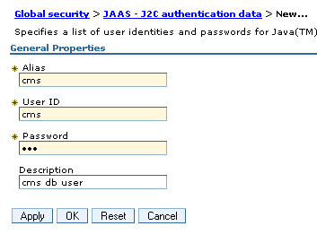

- Apply and Save the configuration changes

- Navigate to Resources > JDBC > JDBC Providers, Select you node and click on “New”
- Enter the database type (oracle), provider type (Oracle JDBC Driver), Implementation Type (XA data source). Click Next.
- (Optional) Enter the oracle driver jar and click on “Apply”
- Enter the location of the jar specified then click “Next”
- Review the settings and click “Finish”

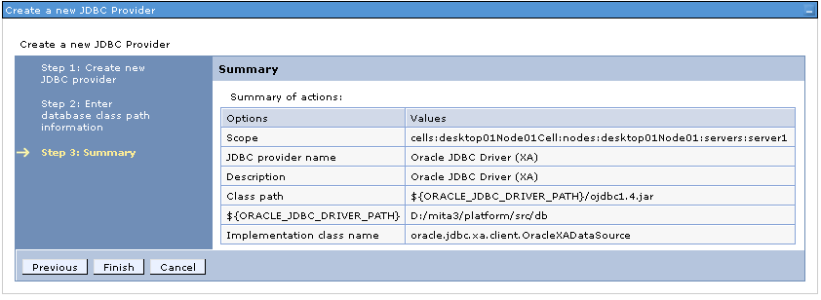

- Create another provider, this time, select the implementation type as Connection Pool Data Source

- Navigate to Resources > JDBC > Data sources, Click on “New”
- Enter the data source name (CMS XA Data Source) and the JNDI name (jdbc/MitaDS)
- Click Next, Select the XA datasource provider created earlier
- Click Next, Enter the database URL. Leave the rest as default.
- Click Next, Select the J2C authentication data created earlier for “Authentication alias for XA recovery”, “Component-managed authentication alias” and “Container-managed authentication alias”. Leave the rest as default.
- Click On Next, Finish then Save. Test your data source.

- Create another DS. Click On “New”
- Enter the name (CMS Task Service Data Source) and JNDI name (jdbc/TaskServiceDS)
- Click Next. Select the connection pool datasource provider created earlier.
- Click Next. Enter the database URL, uncheck the box “Use this data source in container managed persistence (CMP)”
- Click Next. Select the J2C authentication data created earlier for “Component-managed authentication alias” and “Container-managed authentication alias”
- Click On Next, Finish then Save. Test your data source.

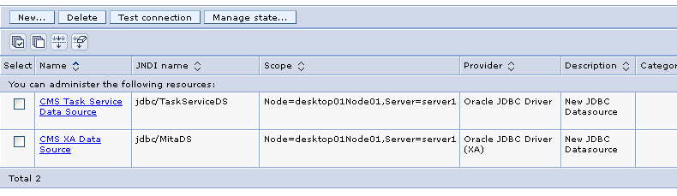

- Navigate to Resources > Mail > Mail sessions. Click “New”
- Enter the name (CMS Mail Session) and the JNDI Name (mail/Session).
- Enter your mail server settings (only outgoing is necessary)
- Leave the rest as defaults
- Click on “Apply”, then Save.

Build Scripts Setup

    - application/build.xml

The following targets are available:

build-core Builds the core archive
build-ejb Build the EJB archive
build-war Builds the web archive
clean Removes all generated files
dist Generates the portal ear artifact
regenerate-model Regenerates the application model from the schemas

(some old targets for jboss are kept)

    - application/build.properties

// this is the only property relevant to websphere deployment
was.home – location of websphere 8.5

Configuration Files

    - services/src/main/resources/cms.properties

Contains the application settings, unless you will use different JNDI names, you can leave this as is for this assembly.

Deployment Instructions

- Setup oracle and websphere per instructions above
- execute “ant dist”, this will create the archive under the folder “build”

- Log in to the WAS console
- Navigate to Applications > Application Types > Websphere enterprise applications
- Click “Install” and upload the generated ear file from by ant script
- Click Next. Accept All Defaults for all the screens
- Click On Finish, wait for installation to complete, then click Save.
- Select the application and click “Start”, the status should turn green

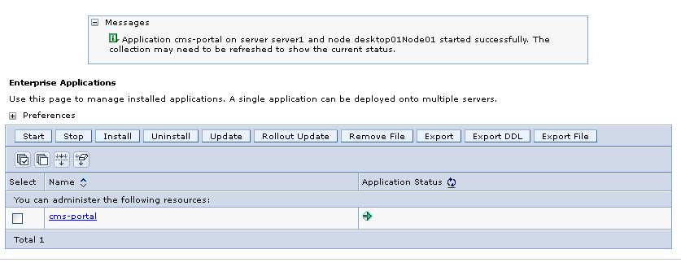

Starting

The app is started through the websphere console (see Deployment Instructions).

Verification

- Open http://localhost:9080/cms/login
- Login via admin/admin
- Perform regression testing such as save/submit/approve

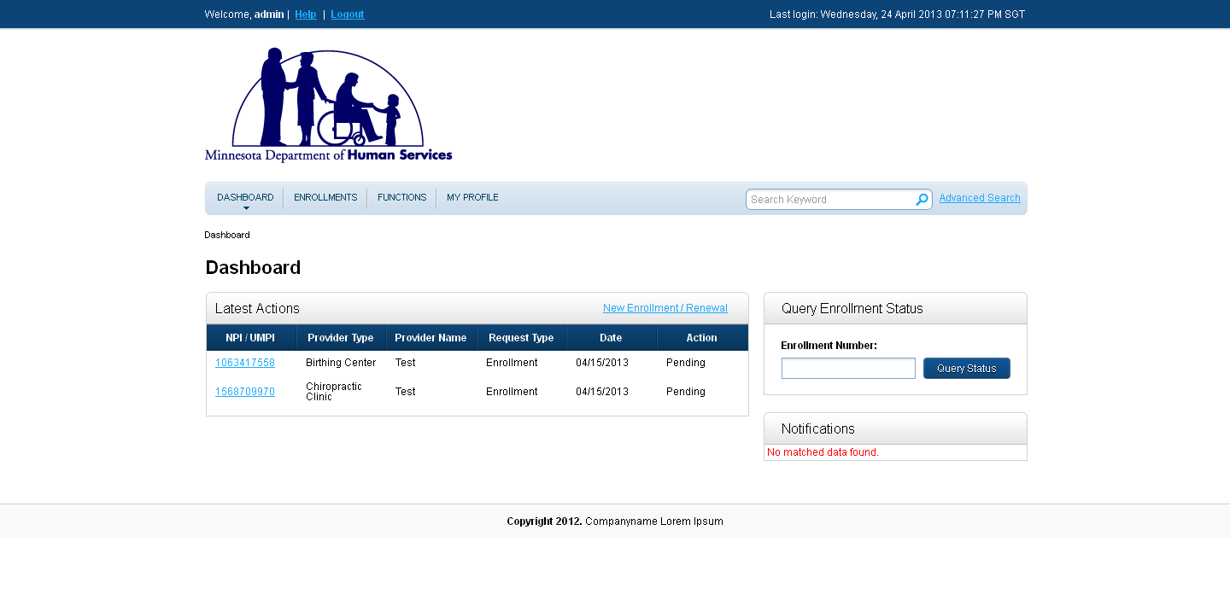

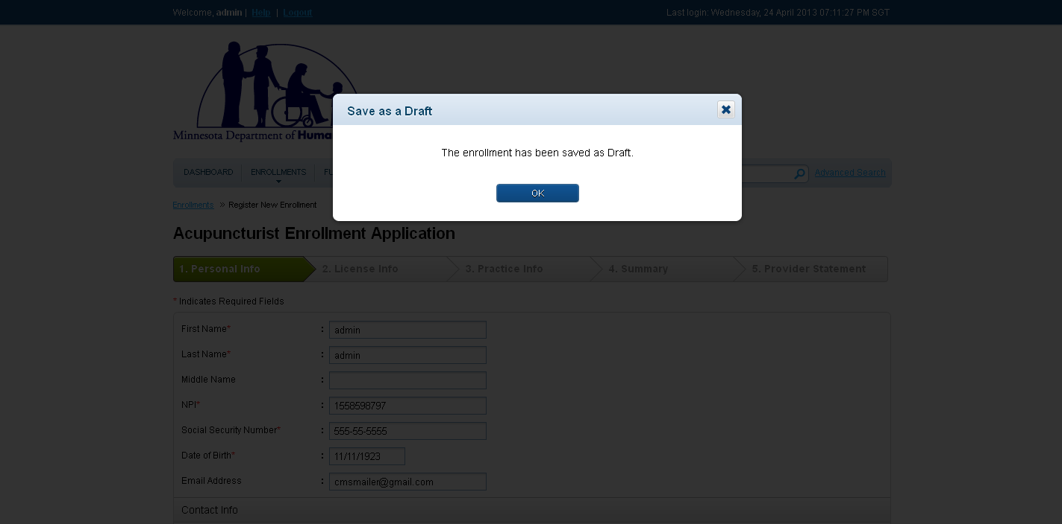

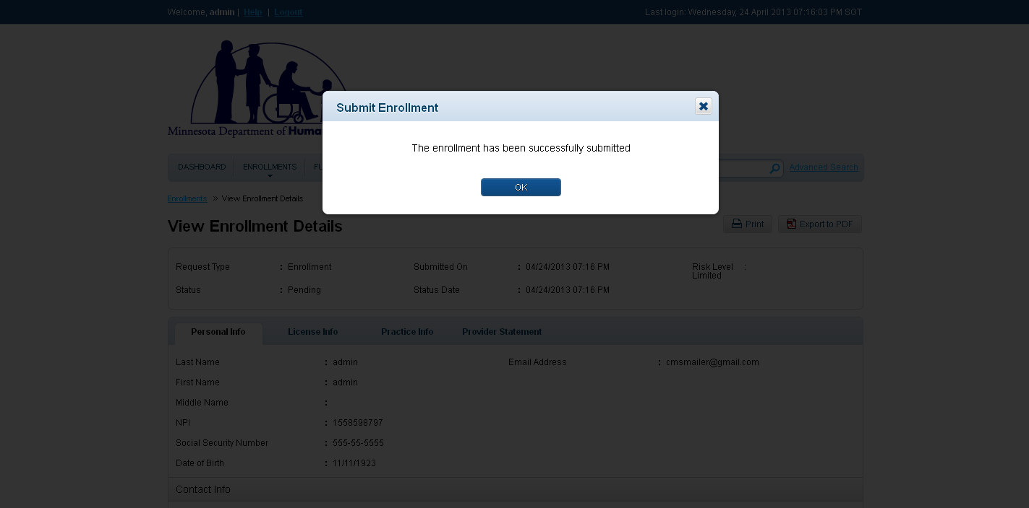

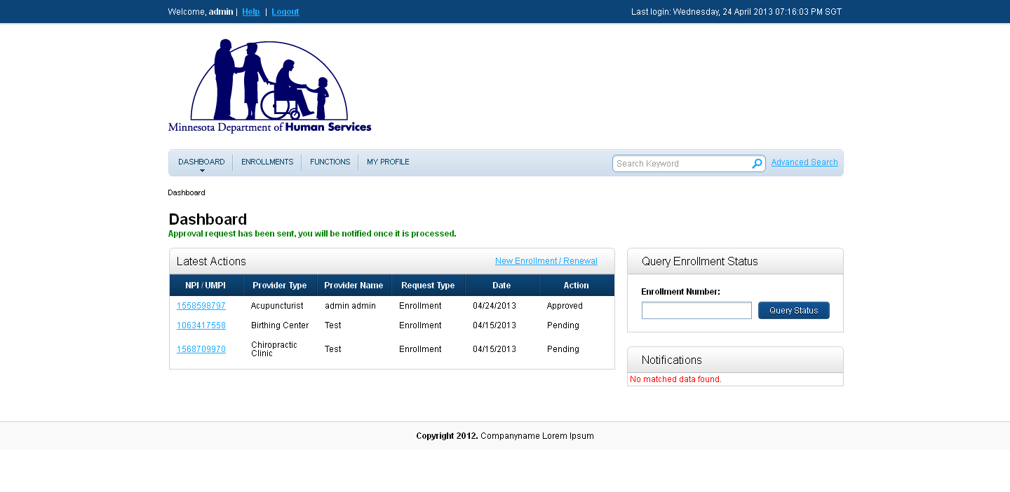

Resource Contact List

Name | Resource Email

